Project Design Phase-II
Data Flow Diagram & User Stories

Date | 29 June 2026
Team ID
Project Name | Smart Agricultural Production Optimization Engine
Maximum Marks | 4 Marks

Data Flow Diagrams:
A Data Flow Diagram (DFD) is a traditional visual representation of the information flows within a system. A neat and clear DFD can depict the right amount of the system requirement graphically. It shows how data enters and leaves the system, what changes the information, and where data is stored.

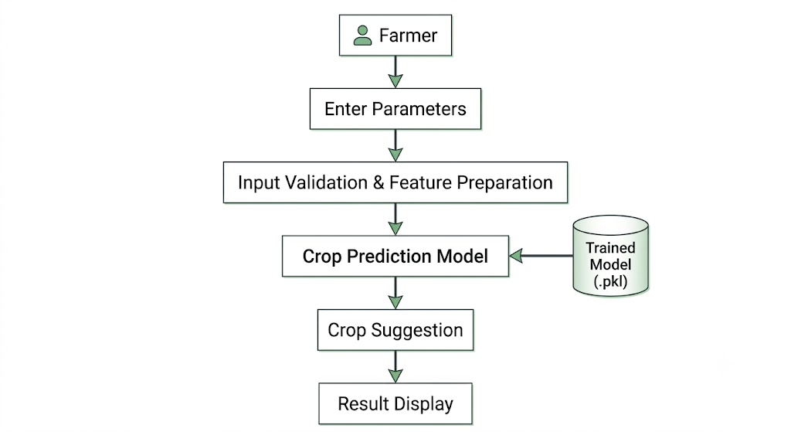
User Stories
User Type | Functional Requirement | User Story No. | User Story | Acceptance Criteria | Priority | Release
Farmer | Soil Data | US-1 | As a farmer, I want to enter Nitrogen (N), Phosphorus (P), and Potassium (K) values so that the system can analyze my soil nutrients. | N, P, and K values accepted successfully. | High | Sprint 1
Farmer | Soil Data | US-2 | As a farmer, I want to enter the soil pH value so that the system can evaluate soil suitability. | pH value accepted successfully. | High | Sprint 1
Farmer | Environmental Data | US-3 | As a farmer, I want to enter temperature, humidity, and rainfall values so that environmental conditions can be analyzed. | Environmental parameters accepted successfully. | High | Sprint 1
Farmer | Input Validation | US-4 | As a farmer, I want the system to validate my soil and environmental inputs before generating recommendations. | Invalid or incomplete inputs are detected and appropriate messages are displayed. | High | Sprint 1
Farmer | Crop Recommendation | US-5 | As a farmer, I want the system to recommend the most suitable crop based on my soil and environmental conditions. | Recommended crop is generated successfully. | High | Sprint 2
Farmer | Prediction Results | US-6 | As a farmer, I want to view the recommended crop on the results page after submitting my inputs. | Crop recommendation is displayed successfully. | High | Sprint 2
Farmer | Machine Learning Prediction | US-7 | As a farmer, I want the system to use a trained machine learning model for accurate crop prediction. | Prediction is generated using the trained model. | Medium | Sprint 2
Farmer | User Interface | US-8 | As a farmer, I want a simple and easy-to-use interface for entering my farm data and viewing recommendations. | User can navigate the application and obtain recommendations without difficulty. | Medium | Sprint 3

